|  |  |  |  |
| --- | --- | --- | --- |
| **Title** | **Year** | **Methodology** | **Remarks** |
| A Comprehensive Approach to Vitamin Deficiency Detection through Image Analysis of Skin, Tongue, Eyes and Nail Images using Convolutional Neural Networks | 2023 | AI and image processing, especially using Convolutional Neural Networks (CNNs), offer promising solutions for early detection and diagnosis of such deficiencies.  Integrating AI-driven image processing technologies into healthcare systems can revolutionize the detection and management of nutrient deficiencies, enhancing public health initiatives | * **Data Collection and Diversity**: It's essential to collect a diverse range of visual data from individuals to train the AI model effectively. Mentioning the methods used to collect and validate visual data, as well as any efforts to ensure diversity in the dataset, would enhance the credibility of the research. |
| Automated glaucoma screening method based on image segmentation and feature extraction | 2022 | A gradient boosting decision tree (GBDT) classifier for glaucoma screening is trained  Using eye image dataset | * Insufficient Discussion on Data Acquisition and Visualization. * The combination of clinical measurement features and hidden texture and statistical features can obtain abundant evidence for glaucoma discrimination and greatly improve the accuracy of glaucoma screening classifier |
| Vitamin And Nutritional Deficiencies Cause Skin And Nail Changes | 2015 | Image processing technologies into healthcare systems can revolutionize the detection and management of nutrient deficiencies, enhancing public health initiatives | * Dermatologic signs of biotin deficiency include thinning of hair and hair loss, patchy red rash (most commonly near the mouth), seborrheic dermatitis and fungal skin and nail infections. |
| Adult blindness secondary to vitamin A deficiency associated with an eating disorder | 2004 | This case report provides a clinical, ophthalmologic, and laboratory description in addition to a review of the medical literature | * The present report indicates that vitamin A deficiency secondary to eating disorders should be considered in the differential diagnosis of patients with severe dry eye and corneal ulceration. |
| Glossitis with linear lesions: An early sign of vitamin B12 deficiency | 2009 | Oral linear lesions associated with vitamin B12 deficiency. We suggest that this presentation is evocative of the deficit and precedes the onset of macrocytic anemia. | * Low data to find the glossitis with linear lesions is characteristic of vitamin B12 deficiency in its early phases. |
| Atrophic glossitis from vitamin B12 deficiency: a case misdiagnosed as burning mouth disorder | 2005 | The case presented in this article demonstrates that it is appropriate and necessary to screen for correctable causes in patients with burning mouth pain. Obtaining a meticulous history and physical examination in conjunction with ordering relevant laboratory tests, including serum levels of vitamin B12 | * Smooth, shiny tongue, demonstrating loss of filiform papillae and central fissuring. These findings fit the classic description of atrophic glossitis and can be seen with vitamin B12 deficiency. |
| Clinical manifestations of the mouth revealing Vitamin B12 deficiency before the onset of anemia | 2019 | Association of manifestations in the mouth and Vitamin B12 deficiency is already known. The signs are not specific to Vitamin B12 deficiency, however they may reveal the deficiency and this is often ignored and leads to delays in diagnosis. | * The combination of clinical measurement features and hidden texture and statistical features can obtain abundant evidence for glaucoma discrimination and greatly improve the accuracy of glaucoma screening classifier |
| Wollina U, Nenoff P, Haroske G, Haenssle HA (July 2016). "The Diagnosis and Treatment of Nail Disorders". Deutsches Arzteblatt International. | 2015 | Evaluation of the nail organ is an important diagnostic instrument. Aside from onychomycosis, which is a common nail disorder, important differential diagnoses | * Nail disorders are a common reason for derma - tologic consultation. They are assessed by clinical inspection, dermatoscopy, diagnostic imaging, microbiological (including mycological) testing, and histopathological examination |

**Figures**

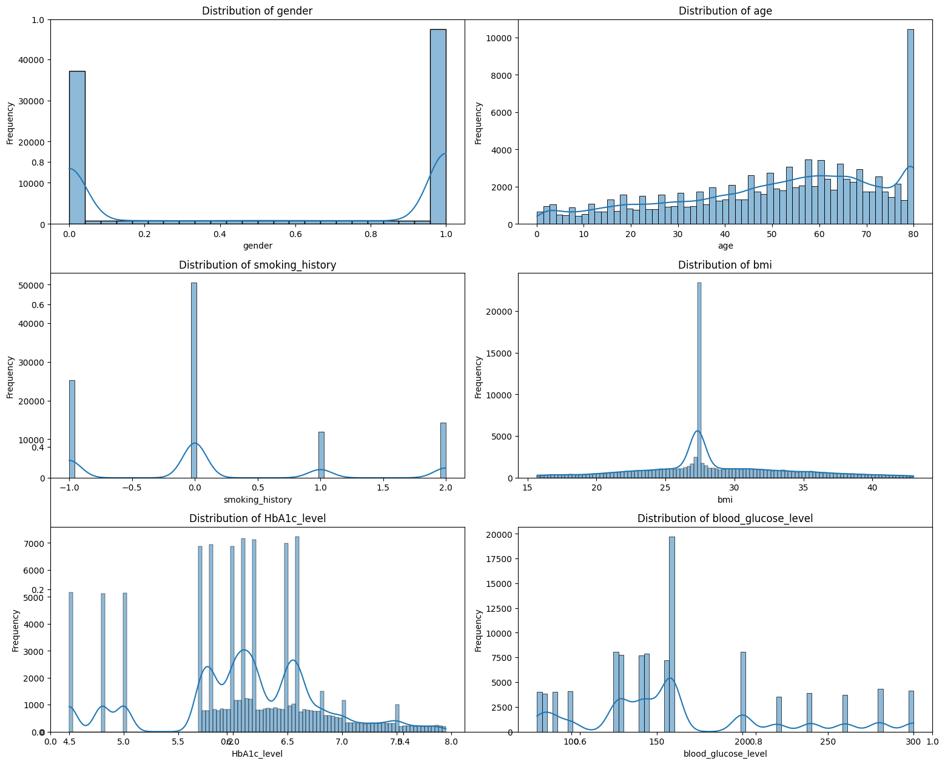

Fig-1: Frequency distribution of each feature.

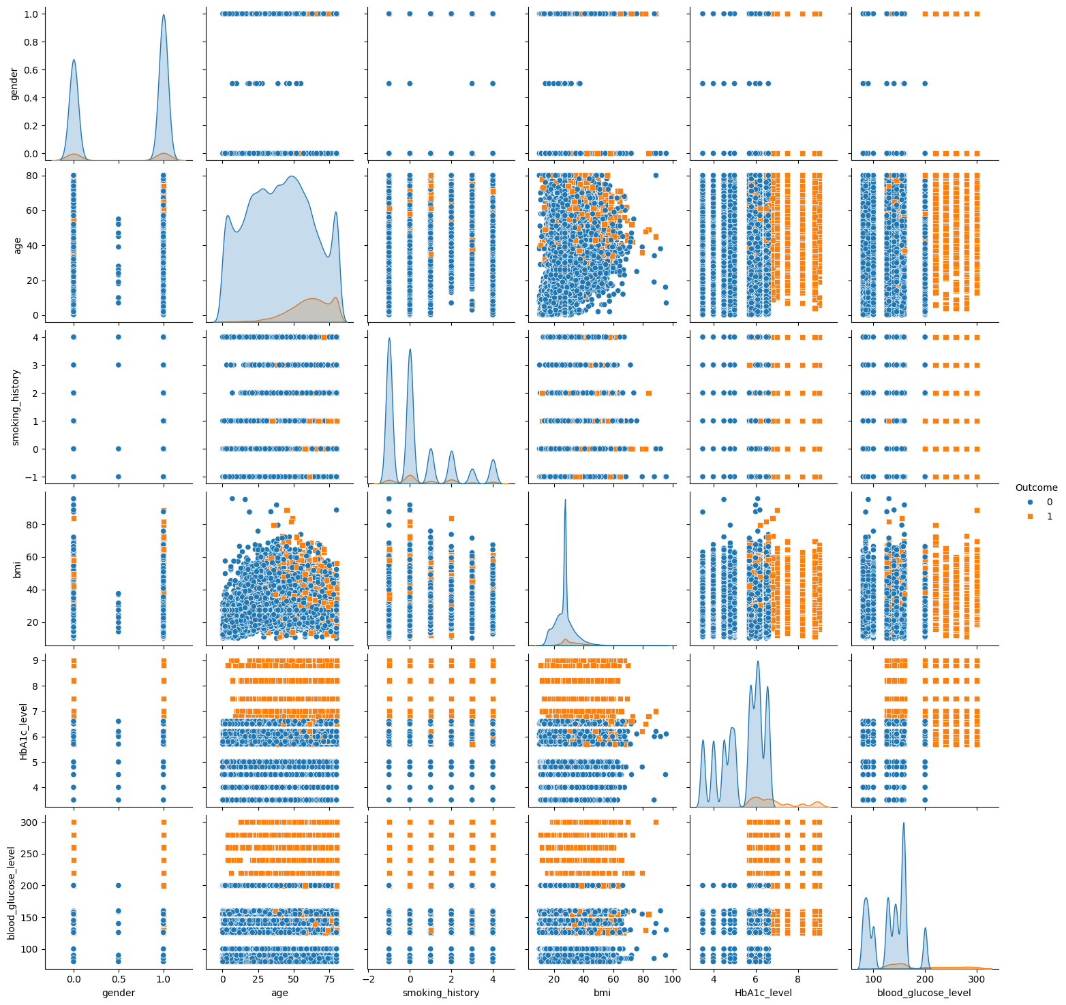 Fig - 2: Correlation plot

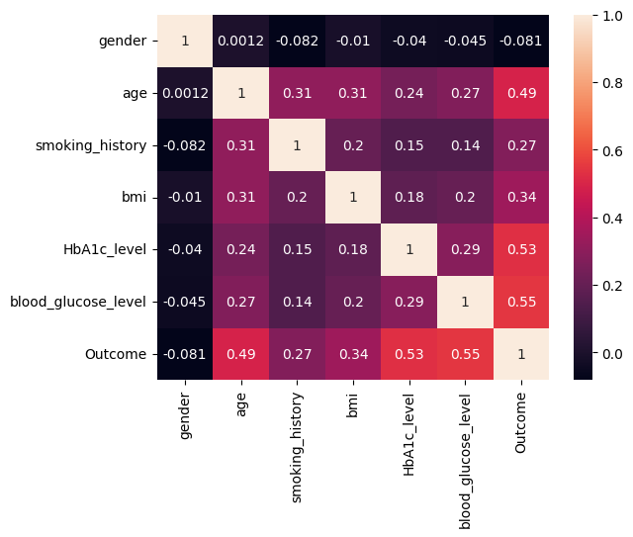

Fig-3: Correlational matrix

|  |  |  |  |
| --- | --- | --- | --- |
| Method /  Algorithm | Splitting Rate ( Training and Testing)  Total rows - 100000 | | |
| 90/10 | 80/20 | 70/30 |
| Random Forest |  |  |  |
| XGBoost |  |  |  |
| Gradient boost |  |  |  |
| Logistic Regression |  |  |  |
| KNN |  |  |  |
| Decision trees |  |  |  |
| CNN |  |  |  |
| Prediction Percentage (%) | Random forest: 96.39 %  XGBoost: 96.61 %  Gradient boosting: 94.64 %  Logistic regression: 87.13 %  KNN: 90.16 %  Decision tree: 95.16 %  CNN: 94.37 % | Random forest: 96.325 %  XGBoost: 96.5099 %  Gradient boosting: 94.855 %  Logistic regression: 80.925 %  KNN: 89.565 %  Decision tree: 94.89 %  CNN: 94.9450001 % | random forest: 96.39333 %  XGBoost: 96.856667 %  Gradient boosting: 95.13667 %  Logistic regression: 87.02 %  KNN: 89.3333 %  Decision tree: 94.933 %  CNN: 94.64 % |